- Create s3 bucket and upload some objects to s3.
Using AWS Console:
- Go to S3 → Create bucket.
  - Bucket name: my-static-website-bucket
  - Region: us-east-1 (or any)
  - Uncheck Block all public access (if hosting a website).
- Click Create bucket.
Upload Objects:
AWS CLI Commands:
- Go to your bucket → Upload → Add files → Upload sample files.
aws s3 mb s3://my-static-website-bucket --region us-east-1
aws s3 cp file1.txt s3://my-static-website-bucket/
aws s3 cp file2.txt s3://my-static-website-bucket/
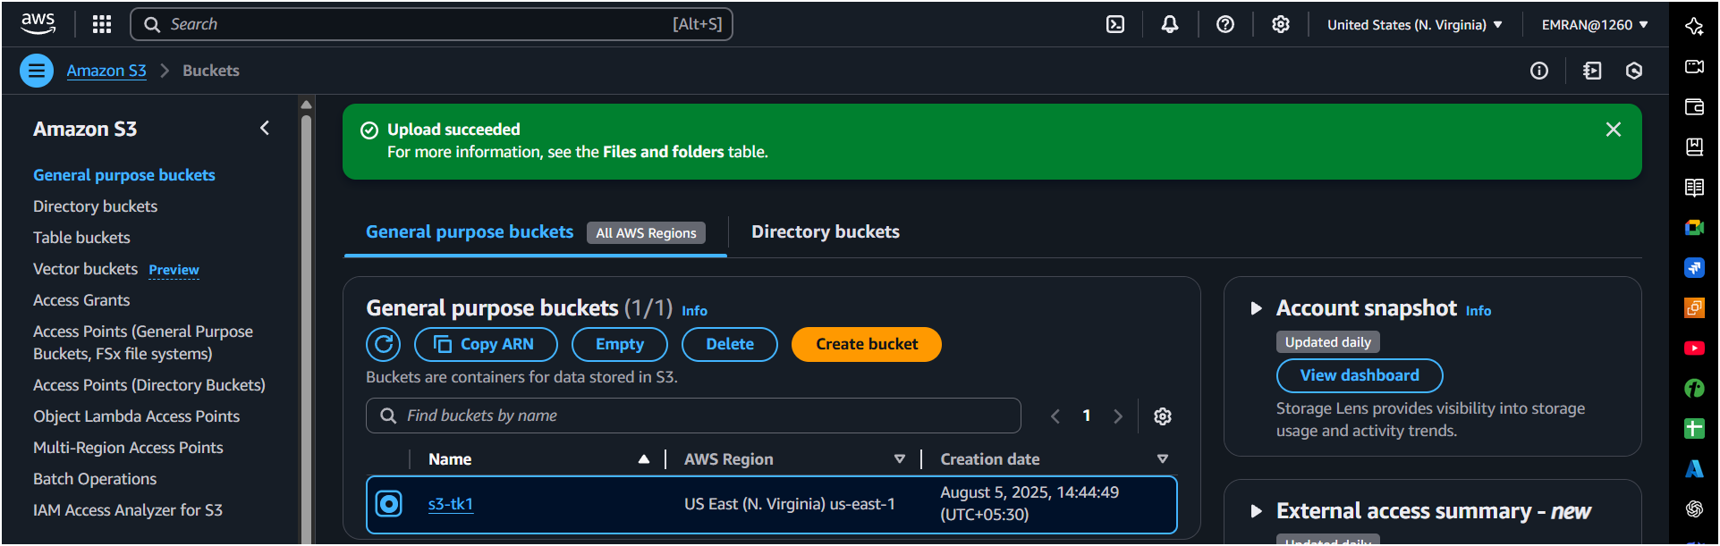

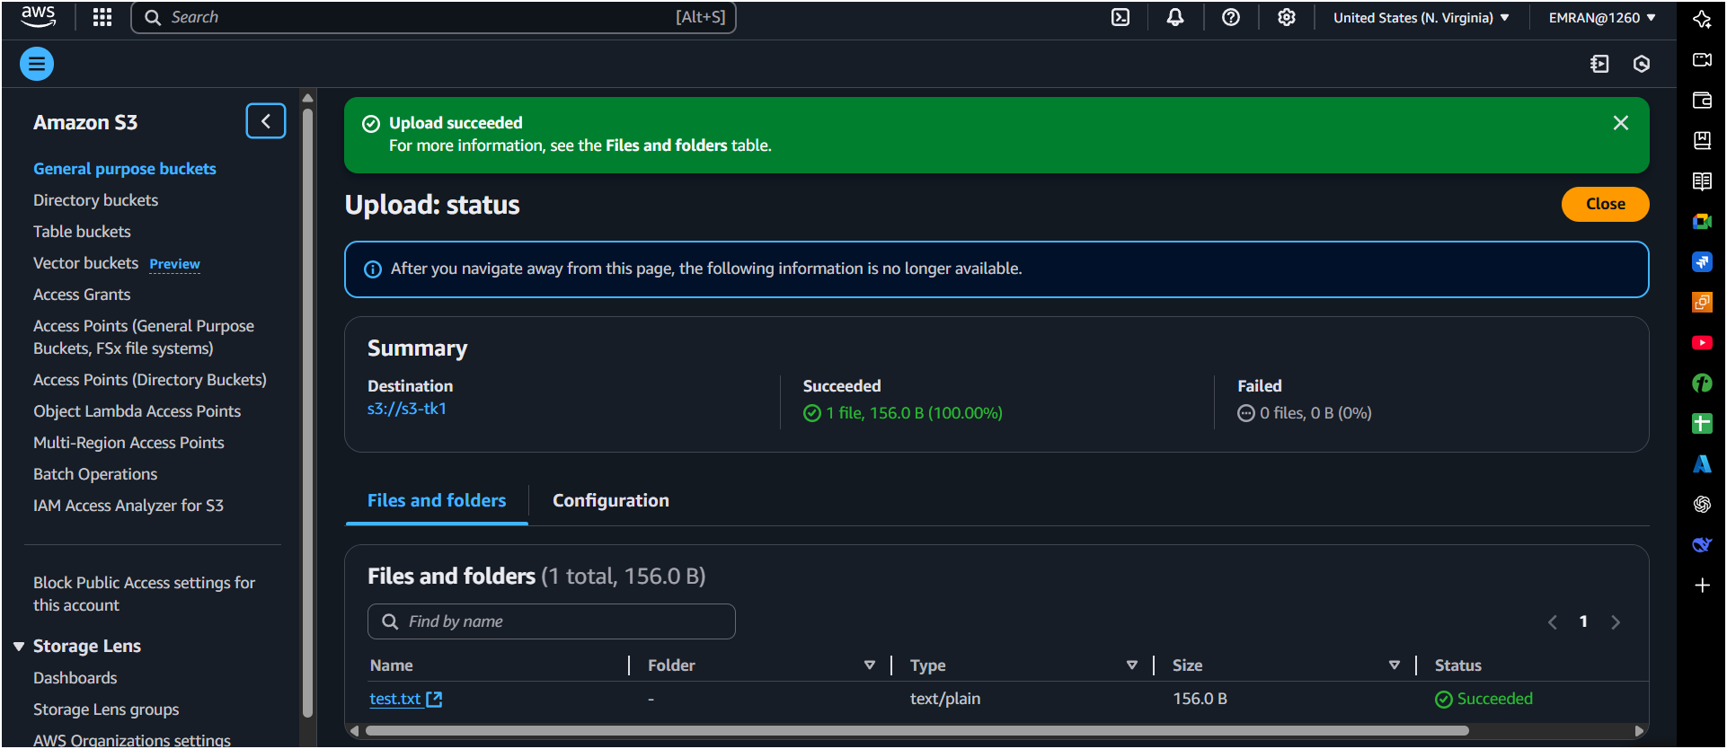

- Deploy static website in s3 bucket.
Steps:
- Go to bucket → Properties → Static Website Hosting → Enable.
  - Hosting type: Host a static website.
  - Index document: index.html.
- Upload index.html and error.html files.
- Make objects public using Bucket Policy
{
"Version": "2012-10-17",
"Statement": [
{
"Sid": "PublicReadGetObject",
"Effect": "Allow",
"Principal": "*",
"Action": "s3:GetObject",
"Resource": "arn:aws:s3:::my-static-website-bucket/*"
}
]
}
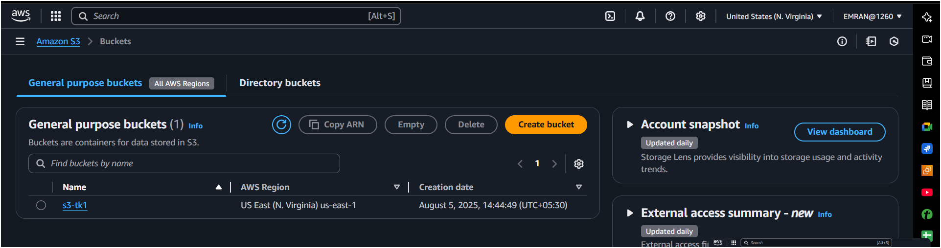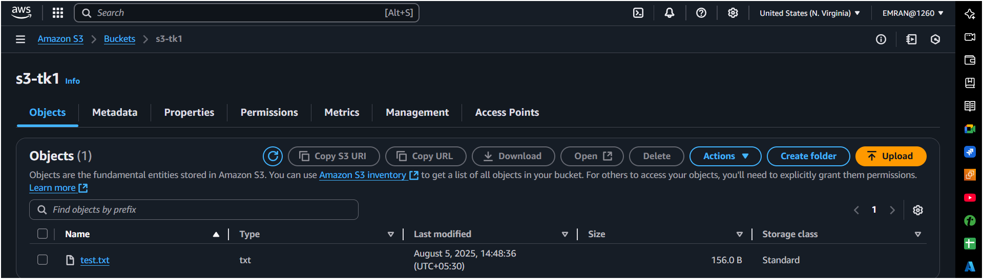
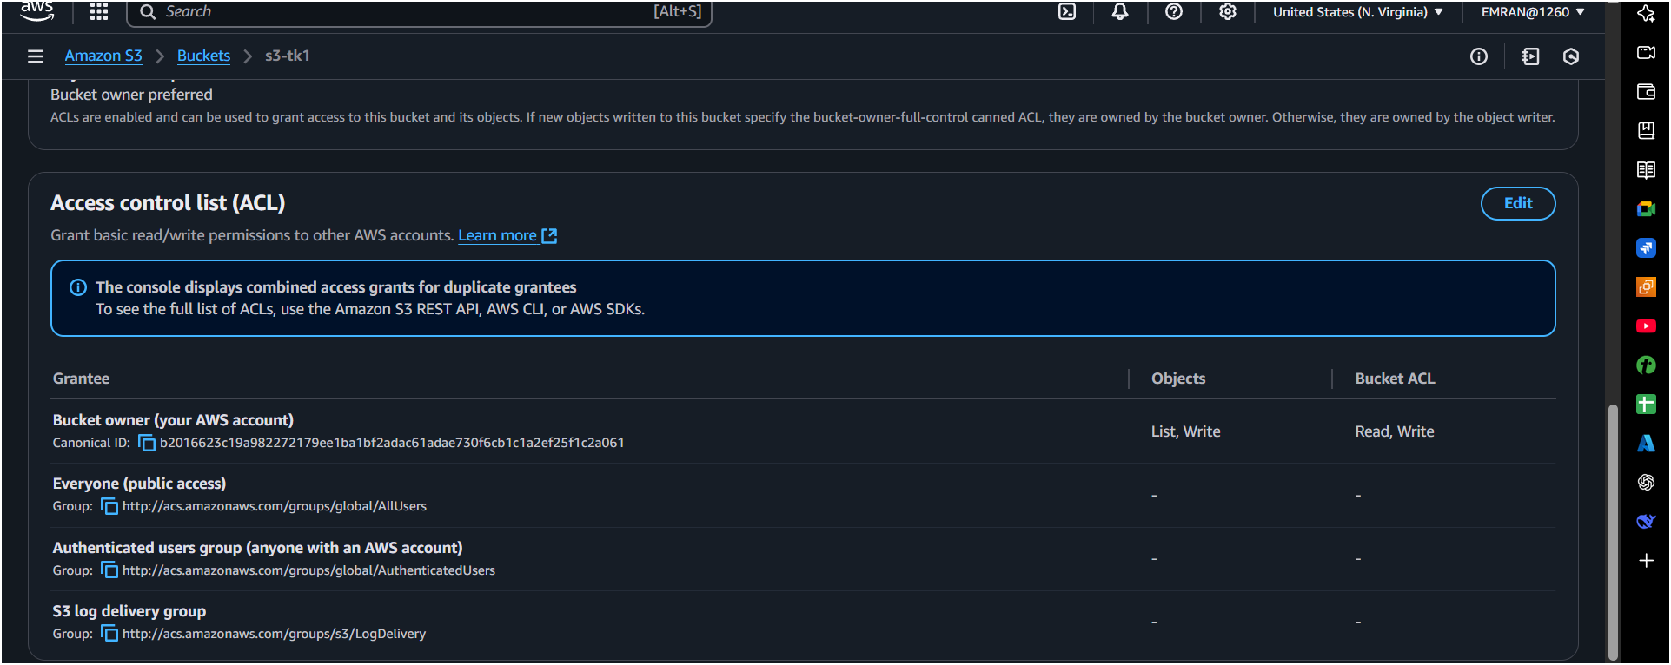

- Enable cross region replication on s3 buckets.
Pre-requisites:
- Versioning must be enabled on both source and destination buckets.
Steps:
- Enable Versioning:
  - In Source bucket and Destination bucket: Go to Properties → Versioning → Enable.
- Go to Source Bucket → Management → Replication → Add rule:
  - Destination: Another bucket in different region.
- Create or choose IAM role for replication.
- Save.

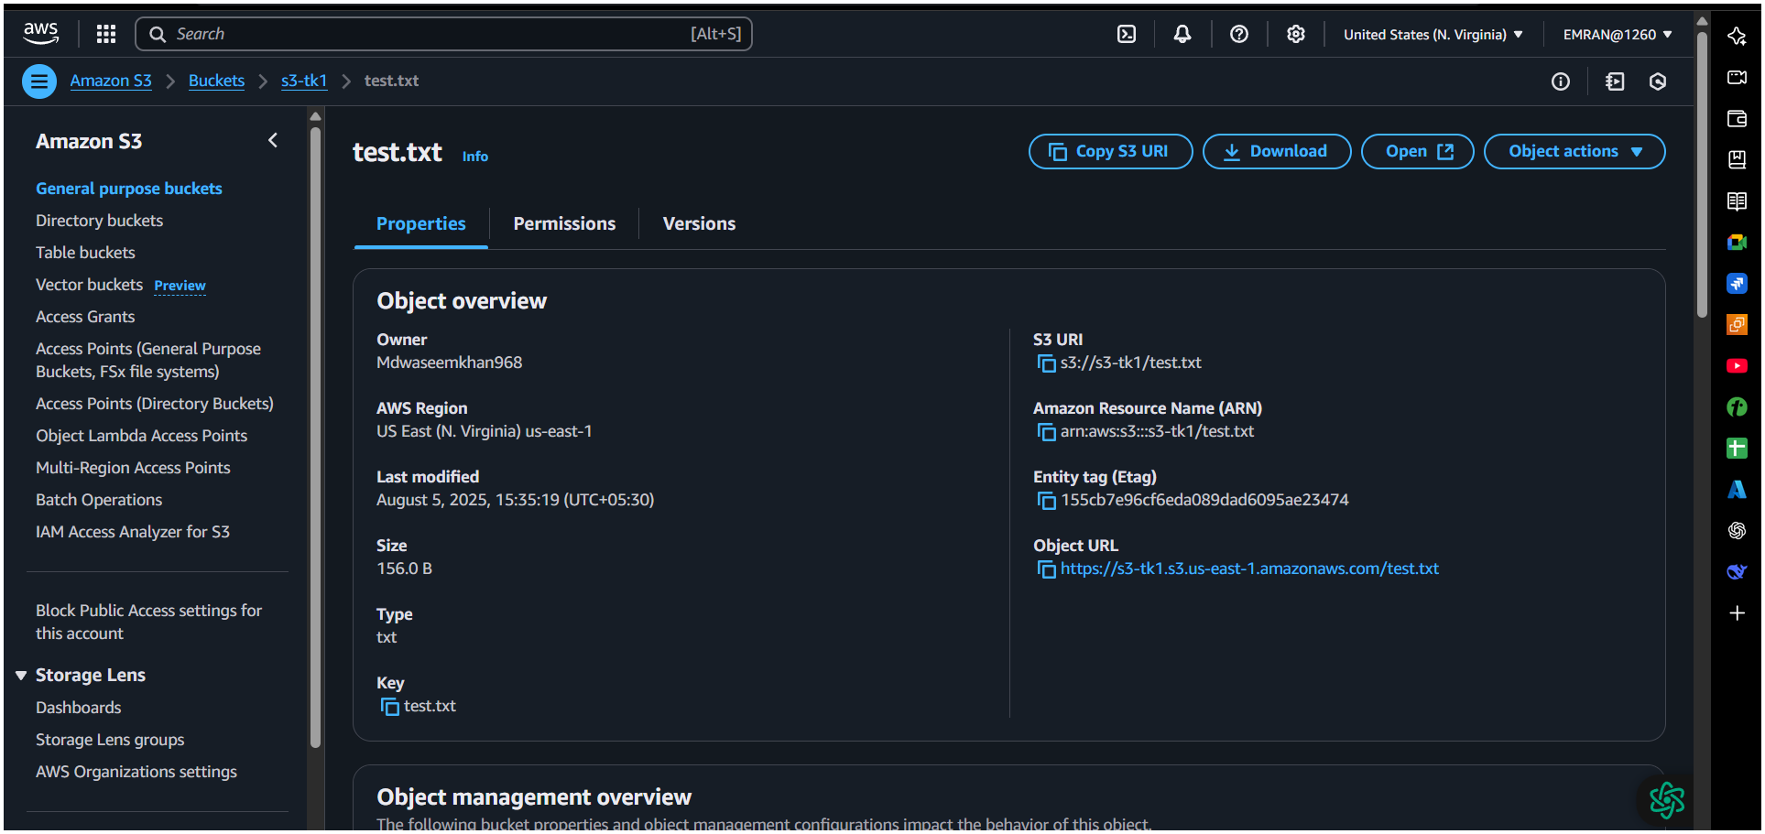
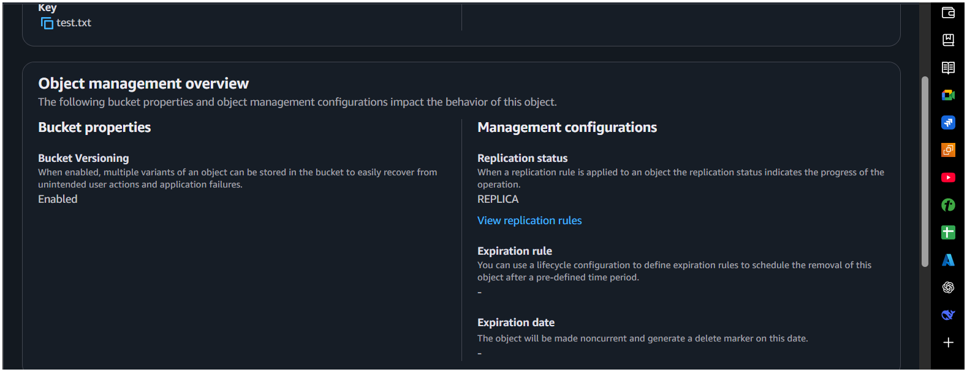
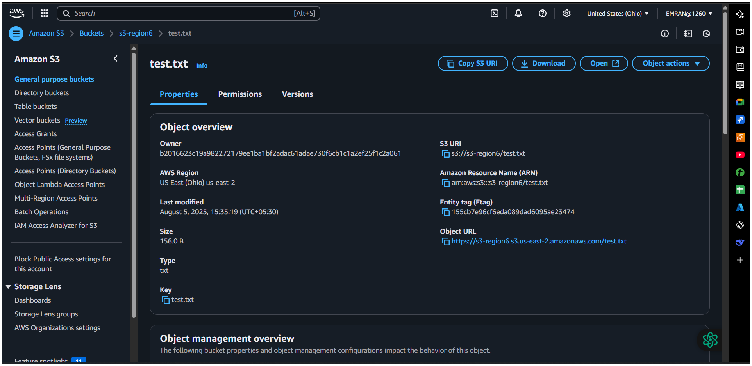
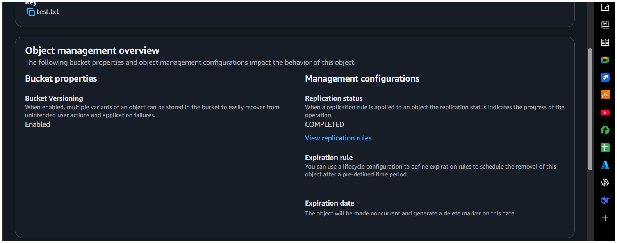
4) Configure bucket policy,only Admin user can see the objects of s3 bucket.
Go to your s3 and create permissions bucket policy,
Assume Admin IAM user ARN:
arn:aws:iam::123456789012:user/Admin
Bucket Policy:

{
"Version": "2012-10-17",
"Statement": [
{
"Sid": "DenyAllUsersExceptAdmin",
"Effect": "Deny",
"Principal": "*",
"Action": "s3:*",
"Resource": [
"arn:aws:s3:::s3-tk1",
"arn:aws:s3:::s3-tk1/*"
],
"Condition": {
"StringNotEquals": {
"aws:PrincipalArn": "arn:aws:iam::520506377811:user/Admin"
}
}
}
]
}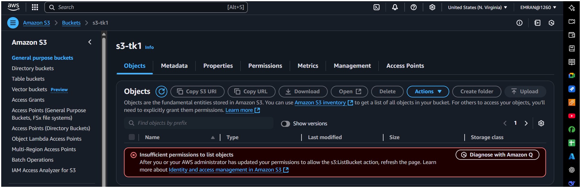
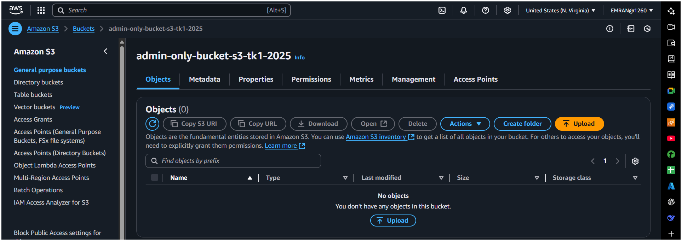

- Setup lifecycle policies to automatically transition or delete objects based on specific criteria.
Steps:
- Go to bucket → Management → Lifecycle Rules → Create rule.
- Set Transition:
  - After 30 days, move to Glacier.
- Set Expiration:
  - After 365 days, delete objects.

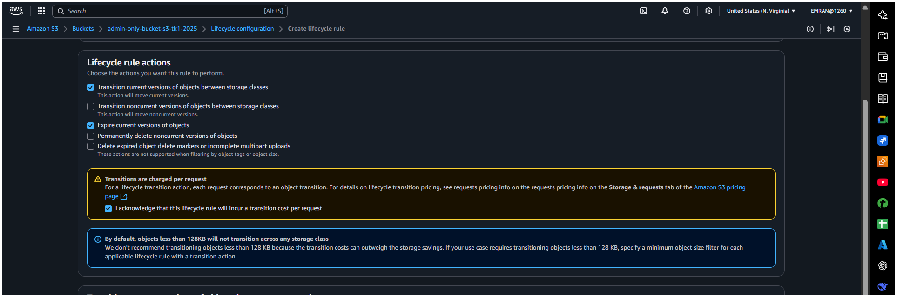
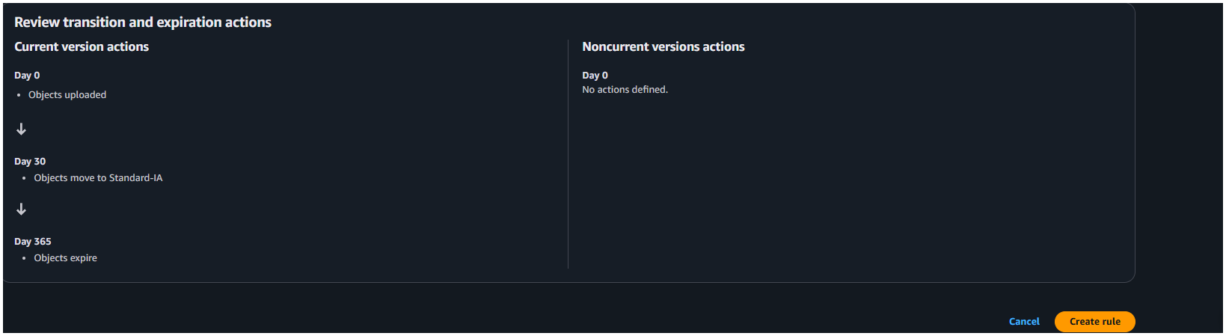
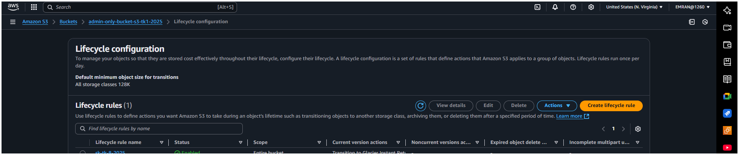
- Push some objects in s3 using AWS CLI.
Upload multiple files:
aws s3 cp /path/to/local/dir s3://my-static-website-bucket/ --recursive

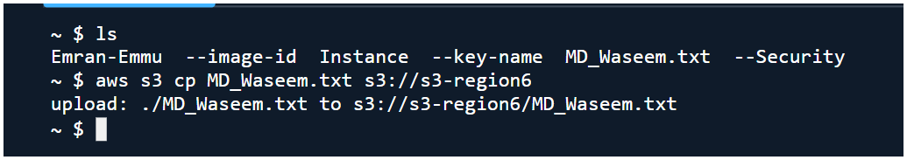
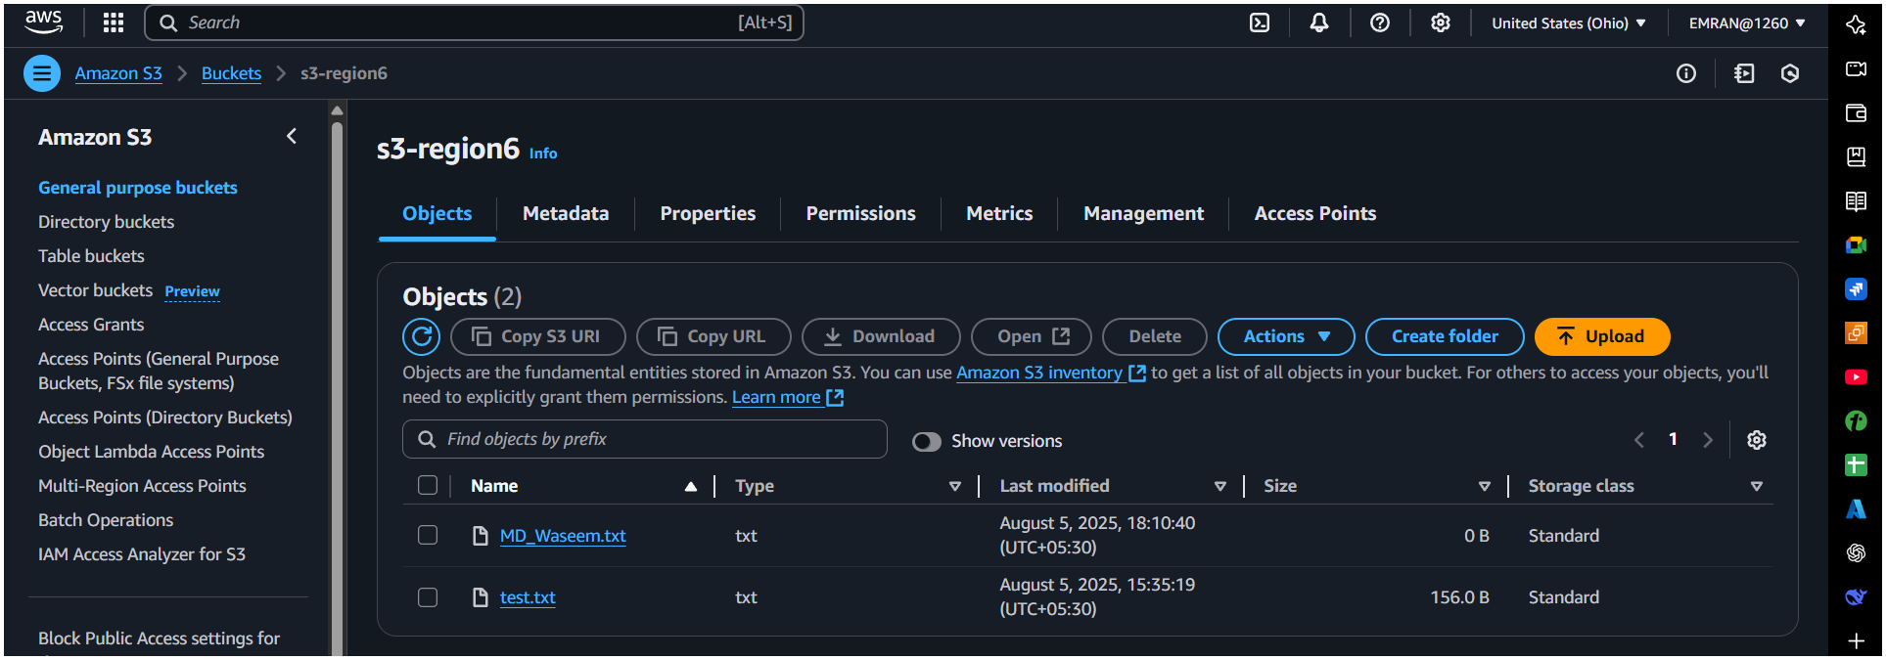

7) Write a bash script to create s3 bucket.
#!/bin/bash
read -p "Enter bucket name: " bucket
read -p "Enter region: " region

aws s3 mb s3://$bucket --region $region

if [ $? -eq 0 ]; then
echo "Bucket $bucket created successfully in $region."
else
echo "Failed to create bucket."
fi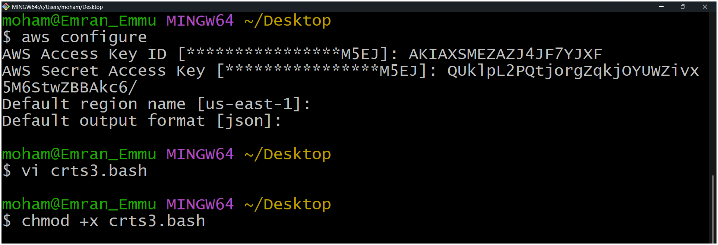
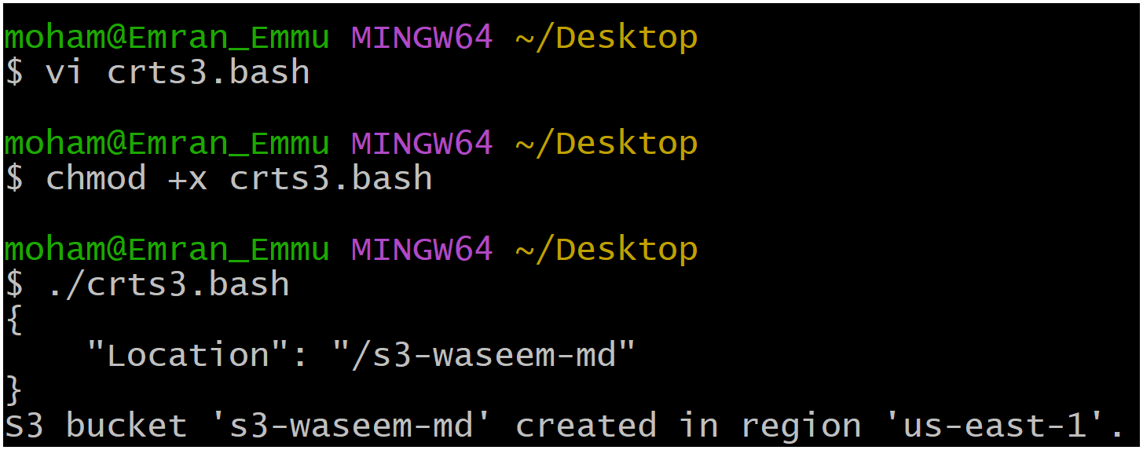
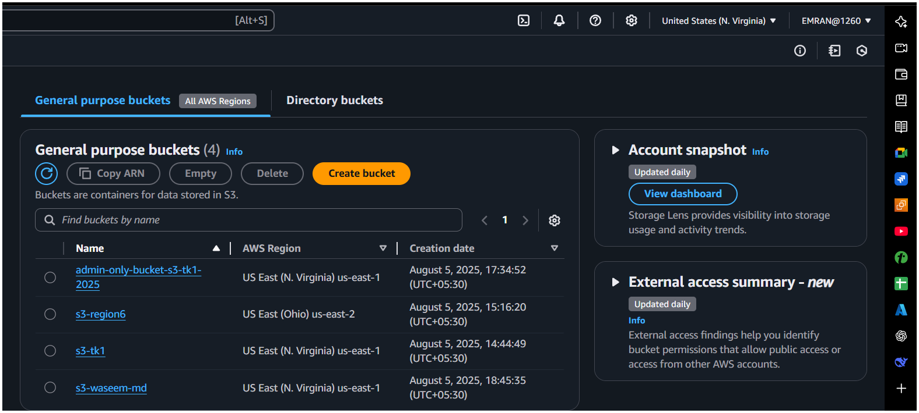
Make executable:
chmod +x create_bucket.sh
./create_bucket.sh
8) Upload one 1 gb of file to s3 using cli.
- Create a 1GB file:
fallocate -l 1G bigfile.txt # Linux
OR
- dd if=/dev/zero of=bigfile.txt bs=1M count=1024
Upload to S3:
aws s3 cp bigfile.txt s3://my-static-website-bucket/

